**Exercise: Playbooks - Run Once**

1. Verify that your ansible installation is available by displaying the version of ansible while logged in as the 'user' user.

[test@tcox3 ~]$ ansible --version

ansible 1.9.2

  configured module search path = None

2. Run the ansible command that lists all of the hosts configured in your control server 'hosts' file for the system.

[test@tcox3 ~]$ ansible all --list-hosts

    tcox5.mylabserver.com

    localhost

    tcox4.mylabserver.com

3. Create a playbook, using the 'RUN ONCE' concepts from the video:

- Uses SSH

- Logs in to the remote system as 'test' user

- Connects to ALL servers

- The playbook runs as 'sudo'

- Skip gathering remote facts

- Runs the remote 'uptime' command and logs it to the remote /home/test directory in a file called 'uptime.log'

- List the remote /var directory and pipe the output to the /home/test directory in a file called 'dir.list'

- Indicate that the directory listing command should only be run ONCE on the first host and not again

[test@tcox3 Playbooks]$ vim runonce.yml   
[test@tcox3 Playbooks]$ cat runonce.yml   
--- # RUNONCE PLAYBOOK EXAMPLE  
- hosts: all  
  user: test  
  sudo: yes  
  connection: ssh  
  gather_facts: no  
  tasks:  
    - name: Run the uptime command on all hosts and log it  
      raw: /usr/bin/uptime >> /home/test/uptime.log  
    - name: List the /var directory and log it  
      raw: ls -al /var >> /home/test/dir.list  
      run_once: true

4. Run the playbook and display the results.

[test@tcox3 Playbooks]$ ansible-playbook runonce.yml   
  
PLAY [all] ********************************************************************   
  
TASK: [Run the uptime command on all hosts and log it] ************************   
ok: [localhost]  
ok: [tcox4.mylabserver.com]  
ok: [tcox5.mylabserver.com]  
ok: [tcox1.mylabserver.com]  
  
TASK: [List the /var directory and log it] ************************************   
ok: [tcox4.mylabserver.com]  
  
PLAY RECAP ********************************************************************   
localhost                  : ok=2    changed=0    unreachable=0    failed=0     
tcox1.mylabserver.com      : ok=2    changed=0    unreachable=0    failed=0     
tcox4.mylabserver.com      : ok=2    changed=0    unreachable=0    failed=0     
tcox5.mylabserver.com      : ok=2    changed=0    unreachable=0    failed=0

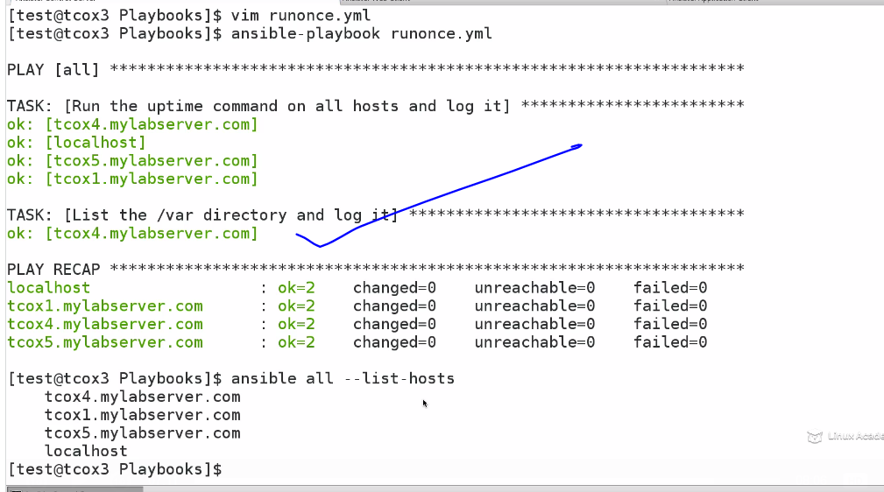

We could see it run only once on 1st host